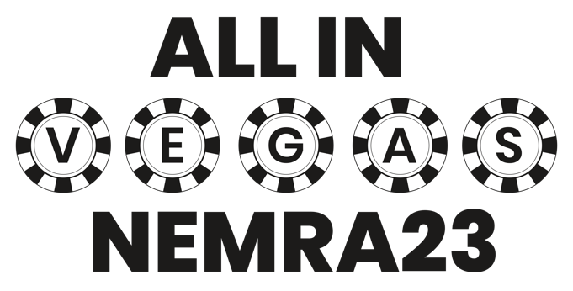

MEETING PLANNER

MEETING PLANNER
Day 1

MONDAY
JANUARY 30
Registration Opens

12:00 – 6:00 PM CST
NEMRA President & Chair Fireside Chat with Q&A

6:00 – 7:00 PM CST
NEMRA Networking Reception

7:00 – 9:00 PM CST


TUESDAY
JANUARY 31
Registration Open

6:00 – 6:00 PM CST
Breakfast

6:00 – 6:45 AM CST
Keynote Session

7:00 – 8:00 AM CST

Exhibitor Booths Open

8:30 – 5:30 PM CST
One-on-One Meeting - Round 1

8:30 – 9:30 AM CST
One-on-One Meeting - Round 2

9:45 – 10:45 AM CST
One-on-One Meeting - Round 3

11:00 – 12:00 PM CST
One-on-One Meeting - Round 4

12:15 – 1:15 PM CST
One-on-One Meeting - Round 5

1:30 – 2:30 PM CST
One-on-One Meeting - Round 6
2:45 – 3:45 PM CST
One-on-One Meeting - Round 7

4:00 – 5:00 PM CST
One-on-One Meeting – Round 8
5:15 – 6:15 PM CST

MEETING PLANNER
Day 2
MEETING PLANNER
Day 3
WEDNESDAY
FEBRUARY 1
Registration Open

6:00 – 5:00 PM CST
Breakfast

6:00 – 7:00 AM CST
Exhibitor Booths Open

8:00 – 5:00 PM CST
One-on-One Meeting - Round 9

7:00 – 8:00 AM CST
One-on-One Meeting - Round 10

8:15 – 9:15 AM CST
One-on-One Meeting - Round 11

9:30 – 10:30 AM CST
One-on-One Meeting - Round 12

10:45 – 11:45 AM CST
One-on-One Meeting - Round 13

12:00 – 1:00 PM CST
One-on-One Meeting - Round 14

1:15 – 2:15 PM CST
One-on-One Meeting - Round 15

2:30 – 3:30 PM CST
One-on-One Meeting - Round 16

3:45 – 4:45 PM CST
One-on-One Meeting - Round 17

5:00 – 6:00 PM CST
THURSDAY
FEBRUARY 2
Registration Open

6:00 – 5:00 PM CST
Grab n Go Breakfast

6:00 – 7:00 AM CST
Expo Open

8:00 – 2:00 PM CST
One-on-One Meeting - Round 18

7:00 – 8:00 AM CST
One-on-One Meeting - Round 19

8:15 – 9:15 AM CST
One-on-One Meeting - Round 20

9:30 – 10:30 AM CST
One-on-One Meeting - Round 21

10:45 – 11:45 AM CST
One-on-One Meeting - Round 22

12:00 – 1:00 PM CST
One-on-One Meeting - Round 23

1:15 – 2:15 PM CST
One-on-One Meeting - Round 24

2:30 – 3:30 PM CST
One-on-One Meeting - Round 25

3:45 – 4:45 PM CST
One-on-One Meeting - Round 26

5:00 – 6:00 PM CST
MEETING PLANNER
Day 4

Las Vegas, NV • Virgin Hotel
Jan 30 - Feb 2, 2022

